Iteration 2: Progress Report

Group 1: Cullen Martin, Elton Sinclair, Jayden Pearce

Cullen’s Contributions:

* Completing the resource needs table

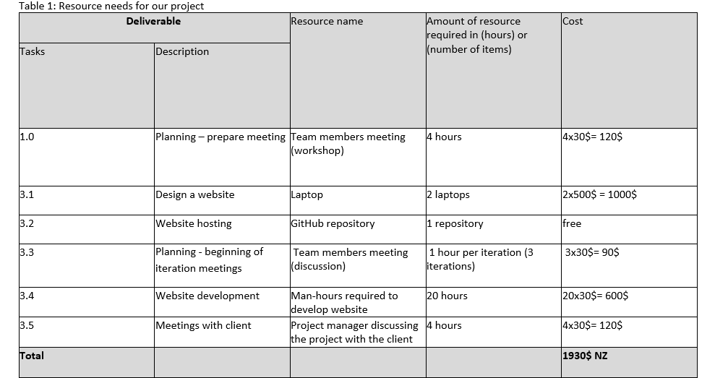

* Writing this progress report

Elton’s contributions:

* None

Jayden’s contributions:

* Creating the GitHub repository that Jayden and Cullen have uploaded all their work into.

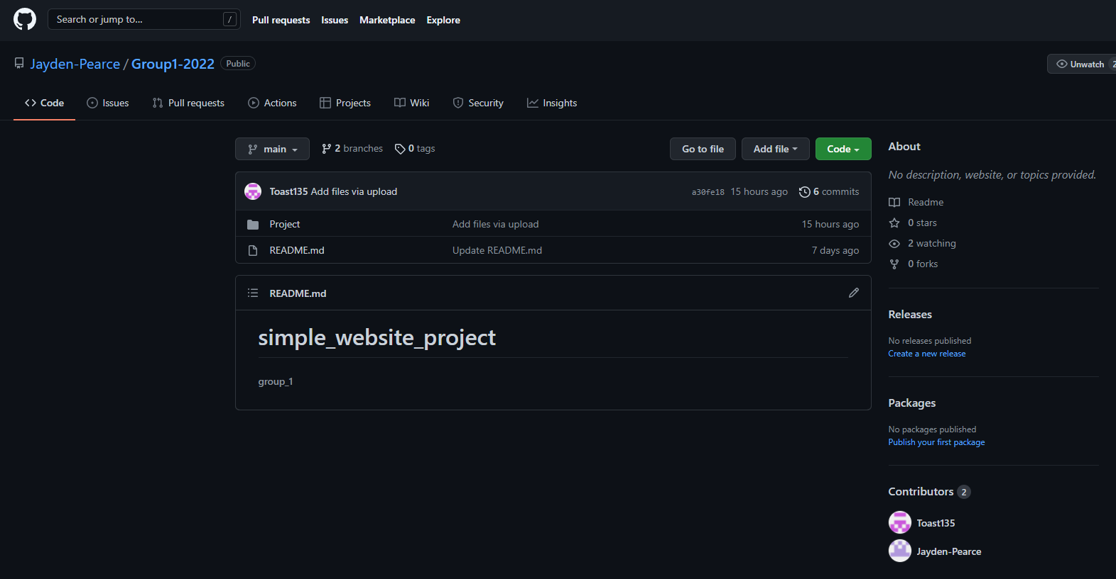

* Creating the project’s Gantt Chart

What's working:

As Elton has not been in contact with the group for iteration 2, Cullen and Jayden have assigned this iteration’s tasks between themselves quite well and there have been no conflicts with how to complete these tasks. Both Cullen and Jayden are still capable of working on their contributions independently when necessary. Cullen and Jayden also have a good understanding of the content of this assignment and have had no troubles with completing their assigned tasks. Communication outside of our in-person meetings has improved since iteration 1 (with the exception of Elton).

What's not working:

Elton has not attended our in-person meetings or responded to any online communication for the entirety of iteration 2. We have begun to split the project’s tasks between Cullen and Jayden until this is resolved.

What needs improving:

Cullen needs to improve his time management for this project as his work is being submitted closer to the deadline that what would be comfortable.